Project Design Phase

Solution Architecture Report
Project: Script-Controlled ACL – Restrict Record Access Based on Field Value
Date | 1 October 2026
Team ID | SWTID-2026-7653
Project Name | Script-Controlled ACL – Restrict Record Access Based on Field Value
Maximum Marks | 2 Marks

1. Architecture objective
The architecture places authorization at the ServiceNow platform ACL layer. Requests from supported access channels are evaluated against the session user, requested operation, role requirements and—in the READ case—the Branch value on the target record. The result is an auditable allow/deny decision before the table data is returned or changed.
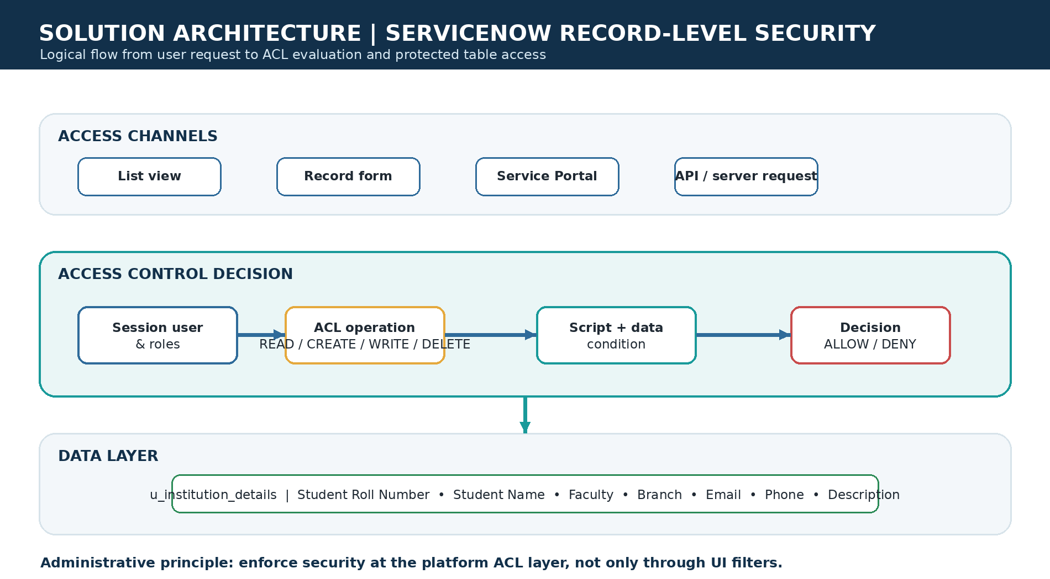
Figure 1. Custom logical architecture and authorization flow.

2. Components and responsibilities
Component | Responsibility | Project implementation
Access channels | Provide list, form, portal or server-side entry points. | Student Records list/form and other ServiceNow interfaces.
Session user and roles | Identify the requester and assigned permissions. | EEE User plus `bb1`, `bb2`, `bb3`, `bb4`; administrator role for bypass.
ACL operation resolver | Select the ACL for READ, CREATE, WRITE or DELETE. | Four record ACLs on `u_institution_details`.
Script and data condition | Evaluate role membership, admin status and record data. | Advanced script plus Branch = EEE condition for READ.
Decision outcome | Allow the operation or deny it. | ServiceNow enforces the decision at the record/table security boundary.
Data layer | Store the protected institution/student records. | `u_institution_details` custom table.

3. Data model
Field | Type / role in model | Security relevance
Student Roll Number | Auto number | Stable record identifier for testing and audit.
Student Name | Reference to User | Identifies the student record subject.
Faculty Name | Reference to User | Identifies faculty or ownership context.
Branch | Choice: ECE, EEE, CSE | Primary data attribute used by the READ condition.
Email | String | Sensitive contact data protected by record access.
Phone Number | String | Sensitive contact data protected by record access.
Description | Multi-string | Additional record context; should follow the same ACL decision.

4. Authorization matrix
Requester state | READ EEE | READ non-EEE | CREATE | WRITE | DELETE
No custom role | Deny | Deny | Deny | Deny | Deny
bb1 | Allow | Deny | Deny* | Deny* | Deny*
bb1 + bb2 | Allow | Deny | Allow | Deny* | Deny*
bb1 + bb2 + bb3 | Allow | Deny | Allow | Allow | Deny*
bb1 + bb2 + bb3 + bb4 | Allow | Deny | Allow | Allow | Allow
admin | Allow | Allow | Allow | Allow | Allow

*The starred outcomes represent the project’s staged permission design; exact record-level behavior for create/write/delete should be confirmed with branch-specific conditions if the production policy requires branch isolation for every operation.

5. Request sequence
- 1. A user opens or attempts an operation on `u_institution_details`.
- 2. ServiceNow identifies the operation (read, create, write or delete) and loads the corresponding ACL.
- 3. The ACL checks the administrator bypass and required role membership.
- 4. For READ, the data condition checks whether the target record has Branch = EEE.
- 5. ServiceNow returns the permitted data/action or denies the request; the UI reflects the outcome through visible records and action controls.

Evidence of the operation-specific ACL setup
The project evidence shows a separate ACL configuration for an operation on `u_institution_details`, supporting the architecture’s operation-specific policy layer.
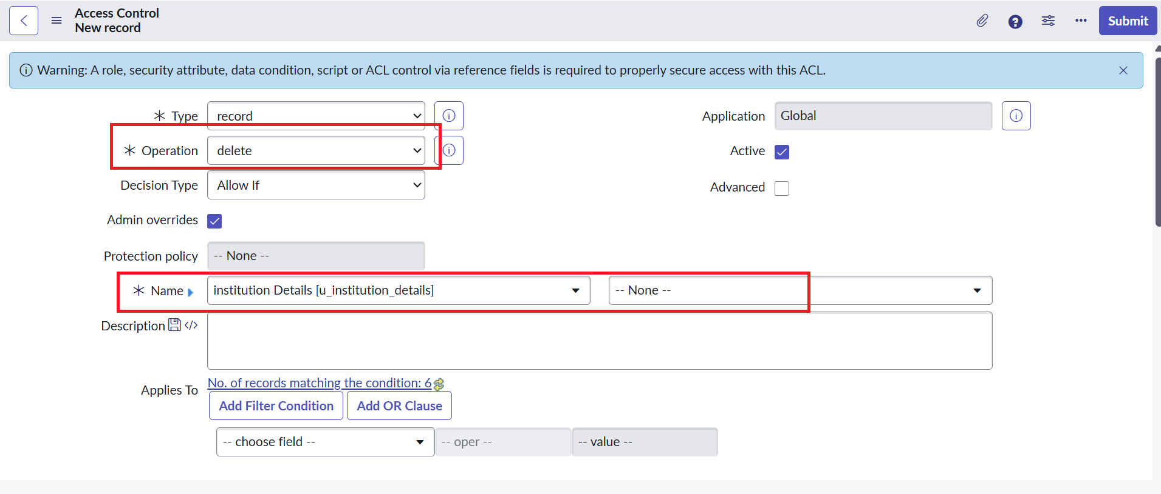
Project evidence screenshot: Evidence of the operation-specific ACL setup

Evidence of the ACL operation and role requirement
The project evidence shows another ACL configuration with an explicit operation and required role, reinforcing the staged permission model.
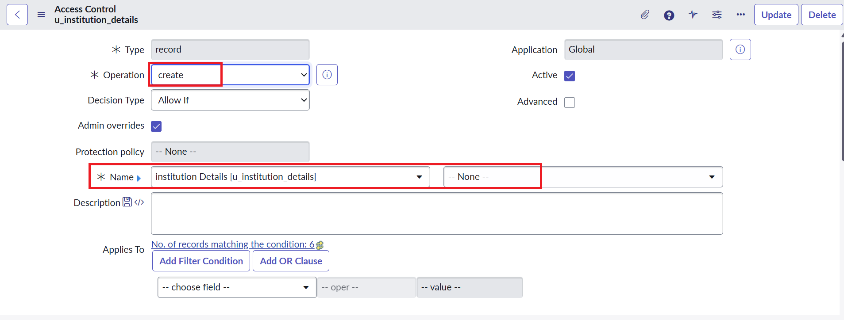
Project evidence screenshot: Evidence of the ACL operation and role requirement

6. Security and quality considerations
- Default deny: explicitly require roles instead of relying on UI visibility.
- Least privilege: assign only the role needed for the user’s operation.
- Defense in depth: retain both role checks and record-field conditions where branch isolation is required.
- Role governance: document who may assign `bb1`–`bb4` and restrict `security_admin` elevation.
- Testability: create automated tests for every role/operation/branch combination and for impersonated users.
- Operational safety: review integrations, background scripts and elevated sessions so they do not unintentionally bypass the intended policy.

7. Architecture conclusion
The architecture is a compact, platform-native authorization design: the table stores the data, roles express capability, ACLs express operation-specific policy, and the script/data condition produces the final decision. It is suitable for the project demonstration and can serve as a reusable pattern for additional tables or branches after the policy matrix and automated verification are expanded.

References
Primary source: project document “Script-Controlled ACL – Restrict Record Access Based on Field Value,” supplied by the project owner. Template structure adapted from the Phase 3 Solution Architecture Template.

